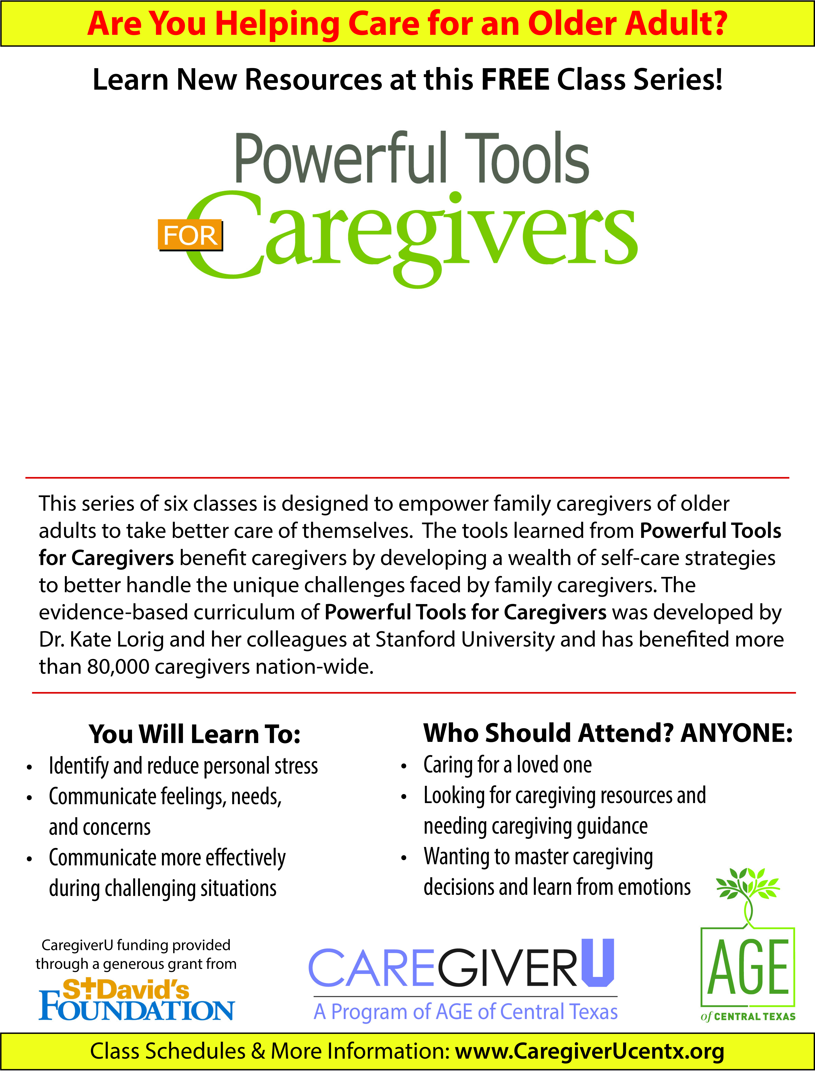
Type your class information here!
Type your class dates and contact information here!

